A Progress Report

on

MUJ CAB SHARING APP

carried out as part of the course CSE CS3270 Submitted by

Shivam Agrawal

209302215

VI-CSE-D

in partial fulfilment for the award of the degree

of

BACHELOR OF TECHNOLOGY

In

Computer Science & Engineering



Department of Computer Science & Engineering,
School of Computing and IT,
Manipal University Jaipur,
March 2023

Acknowledgement

This project would not have completed without the help, support, comments, advice, cooperation and coordination of various people. However, it is impossible to thank everyone individually; I am hereby making a humble effort to thank some of them.

I acknowledge and express my deepest sense of gratitude of my internal supervisor Ms Deepti Sharma for her constant support, guidance, and continuous engagement. I highly appreciate her technical comments, suggestions, and criticism during the progress of this project “MUJ CAB SHARING APP”.

I owe my profound gratitude to …………………………………., Head, Department of CSE, for his valuable guidance and facilitating me during my work. I am also very grateful to all the faculty members and staff for their precious support and cooperation during the development of this project.

Finally, I extend my heartfelt appreciation to my classmates for their help and encouragement.

Registration No. Student Name
209302215 Shivam Agrawal



Department of Computer Science and Engineering
School of Computing & Information Technology

Date: 23 March 2023

CERTIFICATE

This is to certify that the project entitled “( MUJ CAB SHARING APP)" is a bonafide work carried out as Minor Project Midterm Assessment (Course Code: CS3270) in partial fulfillment for the award of the degree of Bachelor of Technology in Computer Science and Engineering, under my guidance by (Shivam Agrawal ) bearing registration number(_209302215_), during the academic semester VI of year 2022-23.

Place: Manipal University Jaipur, Jaipur

Name of the project guide: Ms Deepti Sharma

Signature of the project guide: ______________________

MINOR PROJECT PROGRESS REPORT GUIDELINES

COMPONENTS OF APPLICATION BASED PROJECT REPORT

The sequence in which the project report pages should be arranged and bound should be as follows:

Contents
Page No.
Cover page

Certificate
Abstract

Table of Contents (with page nos)

- Introduction
  - Objective of the project
  - Brief description of the project
  - Technology used
    - H / W Requirement
    - Software Requirement
  - Organization Profile (if applicable)
- Design Description
  - Flow Chart
  - Data Flow Diagrams(DFDs)
  - Entity Relatoinship Diagram(E-R Diagram)
- Project Description
  - Data Base
  - Table Description
  - File/Database Design
- Input/Output Form Design
- Testing & Tools used (if applicable)
- Implementation & Maintenance (if applicable)
- Future scope
- Conclusion
- Bibliography

Objective
The Cab Sharing application will provide a platform for users to book cabs on their preferred routes so that their fare can be minimized.

Brief Description

The Transport management application will provide a platform for users to book cabs on their preferred routes. The application will allow users to create a profile and make their booking, it will also allow drivers to make their profiles and accept the bookings

Technology Used
- Hardware Requirements-
- Android version 5.1
- Ram 2GB
- 45 MB of free disk space

- Software Requirements-

2 .Technology Used
- Data Flow Diagram
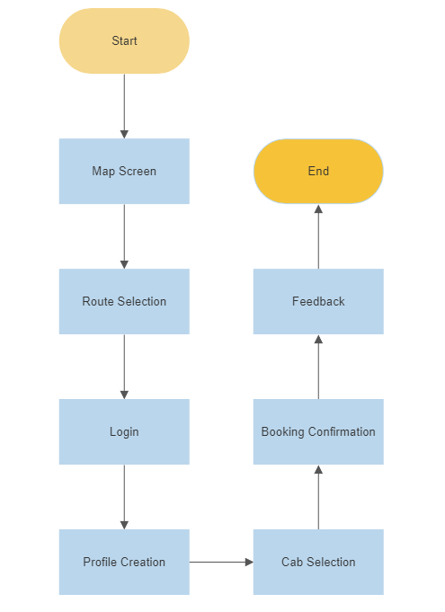

- Entity Relatoinship Diagram(E-R Diagram)
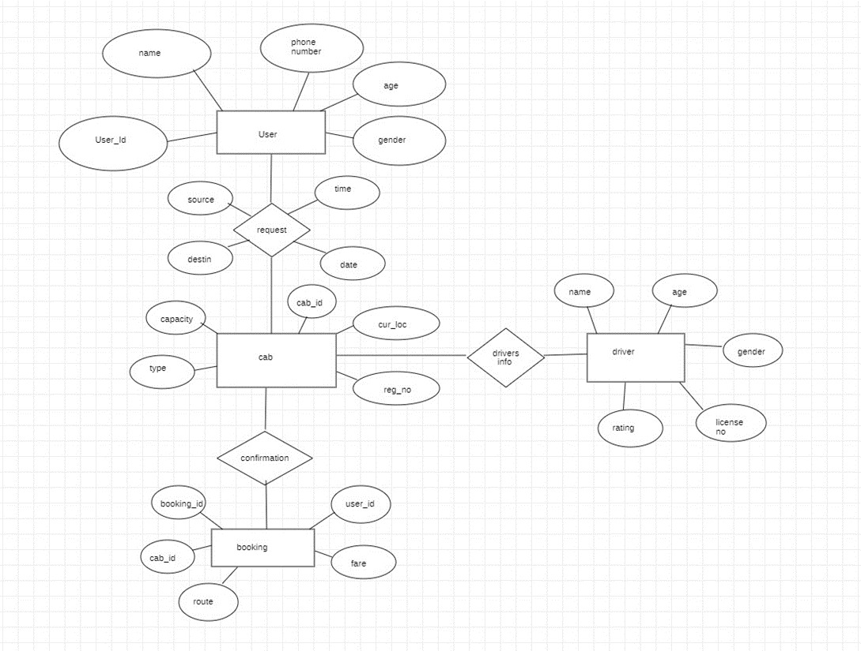

3 .Project Description
- Data Base
  - Firebase
- Table Description

Formatting Details:

The report is to be formatted using Latex/MS-Word Document Preparation System.
Page Format: Margins (left, right, top, bottom – 1 inch), Body text: 12 pt, justified; 1.5” paragraph spacing for text. Figures/ Tables: Place Tables/Figures/Images in the text as close to the reference. Captions should be Times New Roman 10-point. They should be numbered (e.g., “Table 1” or “Figure 2”), please note that the word for Table and Figure are to be spelled out. Figure’s captions should be centred beneath the image or picture, and Table captions should be centred above the table body. Page Numbering, Headers and Footers: Do not include headers, footers. Include page numbers (bottom middle) in your report. Exclude abstract & content page while numbering.

References: List and number all bibliographical references in 10-point Times, single-spaced, at the end of your report. When referenced in the text, enclose the citation number in square brackets, for example [1]. Below are the samples for journal paper, books and Web references.

Samples Journal References - Include year, volume, issue and page numbers
[1] Stahl, D.C., Wolfe, R.W. and Begel, M. (2004). “Improved analysis of timber rivet connections.” J. Struct. Eng., 130(8),

1272-1279.

Sample Books - Include author, book title, publisher, the publisher’s location and chapter title and inclusive of page numbers (if applicable)

[2] Zadeh, L.A.(1981). “ Possibility theory and soft data analysis.” Mathematical frontiers of the social and policy sciences, L. Cobb and R.M. Tharall, eds., Westview, Boulder, Colo., 69-129.
[3] Cotton, F.A. (2003). Chemical applications of group theory, McMilan, London.

Conference Proceedings and Symposiums - Include the sponsor of the conference or publisher of the proceedings and the location-city and state or city and country.

[4] Garrett, D.L. (2003). “ Coupled analysis of floating production systems.” Proc., Int. Symp. on Deep Mooring Systems, ASCE, Reston, Va., 152-167.

Web Pages - Include author, copyright date, title of “page”, web address and date on which the material was downloaded.
[5] Burkha, L.P. (1993). “ A hypertext history of multi-user dimensions.” MUD history, http://www.ccs.neu.edu (Dec. 5, 1994).

CD-ROM - Include authors, copyright date, titles, medium and producer/publisher and its location
[6] Liggett, J.A. and Caughey, D.A. (1998). “Fluid statics.” Fluid mechanics (CD-ROM), ASCE Press, Reston, Va.
Theses and Dissertations - Include authors, copyright date, title and the name and location of the institution where the research was conducted. Note that some institutions use specific terminology; for example, “doctoral dissertation” rather than “Ph.D. thesis”.
[7] Sotiropulos, S.N. (1991). “Statis response of bridge superstructures made of fibre reinforced plastic. “ MTech thesis, West Virginia Univ., Morgantown, W. Va.
Unpublished Material - Unpublished material is not included in the references but may be cited in the text as follows:
[8] John Smith, personal communication, May 16, 1983; J. Smith, (unpublished internal report, ebruary 2003)

